News from Valerie Archer, Missionary Doctor at Kapuna and Kikori, Papua New Guinea

9th June 2024

Dear Family and Friends,

What a wonderful Sunday to write to you all. It is raining and nice and cool. I have the flu – temperature of 37.9° which is not enough to make me sick but enough for people to think that I am sick. Dr Jessley has just returned from her anaesthesia course in Port Moresby and Dr Ruthieane has finished her rural block but not yet left us to go home. So lots of people to work in the hospital and cover for me if I need a day off. So I am making the most of it. I have declared... a Day Off.

I am also trying a new cure for my flu. Everyone tells you and I definitely agree, that you don’t take antibiotics for a viral flu. So I am trying my own holistic “cure”, the “chocolate cure”. April, our friendly YWAM laboratory scientist, aka Father Christmas, has just come to visit us and in her luggage she just happened to have a packet of caramel Easter eggs. Cadbury’s, what’s more! So far, they haven’t cured my cold, but I will send a final report tomorrow when I have taken the full treatment course, i.e. when the packet is empty.

It is Sunday. Most of us go to church on a Sunday morning and enjoy two hours of peace and singing and praying. Thanks to Covid, mask wearing is quite acceptable in church, so no one blinks twice when people come to church sick and coughing as long as they are masked. Very good.

Today we prayed for our Kikori District. We are in a sad state. Two thirds of our health facilities and half of our schools are non functioning. Most of this is due to absent teachers or health workers (still getting paid) and system Corruption so that no one is accountable. But instead of blaming everyone else, or blaming God, for all the problems, we prayed for ourselves to repent and to ask God how we can help. The ladies also did a study on when is the right time to go out and do good things for God. The answer, by the way, in case you can’t guess, is it is always the right time.

About a month ago both Kapuna and Kikori Hospitals went through a very busy period with lots of obstetric complications and worrying sick patients. Things are quiet now, but you never know when they might get busy again. I am trying to keep an eye on both hospitals which both have senior and experienced nurses but just junior doctors running them. I am so grateful our junior doctors. They are doctors we call ‘house surgeons’, only just out of medical school but who are ready and willing to take on any challenge.

And before that we were flat out with patrols. In the wet season it is so wet that no one wants to go on patrol. So, early in the year it is always a rush to get the year’s patrols done before the rain starts. So January, February, March, April and May are the patrol months, and then none until November and December when the weather settles a bit again.

This year we were privileged to join with an organisation called AidOcean who are very definitely a non-Christian group of very dedicated French doctors and nurses. This team were brought in by the French oil company ‘Total’ to do routine immunisation and give medical care to the villages covered by the Oil Company. Our team of two lots of 8 joined them for nearly a month to help with the immunisations and Family Planning. They enjoyed working together though they found each other “very different”.

Almost on top of that, we had a visit from **Samaritan Aviation** with two float planes. Again 8 nurses went out each day, 4 in each plane. SA is a USA based organisation whose mission is to reach people who otherwise have almost no access to medical care. They are hoping to settle in with GCS to work together permanently using float planes to reach people groups on other river systems who we cannot reach easily due to distance and lack of crossing rivers (rivers linking one river system to a neighbouring one).

We are looking at the Turama and Vailala rivers. This time we went to the Turama and visited 4 of the about 20 villages on the river. Most of the people cannot even get access to malaria medicines. It is an exciting big step for us to work closely with another mission group. We now have an MOU together. They are planning to build a hangar, a workshop and some staff houses.

Then, straight after that, we had the Government funded “Hard to Reach” patrols. These are patrols that need a helicopter to get up into the inaccessible mountains. So these were teams of 3 who went to 4 different mountain sites where people knew to gather. Unfortunately, due to bad weather these patrols had been postponed 3 times before, so the people were not really expecting them this time. But the teams were there for 4 days; so it did give people time to walk the one or two days needed for most people to be seen.

So we have had a busy beginning of the year. With extra nurses lectures on top of this, it has been very busy. Thank you for Junior doctors coming to help.

**Restructuring our organisation**

For GCS, our exciting news is that we are ‘restructuring’. Restructuring is what big companies do when they merge or want to get rid of people at the top who are not doing a good job. I hope that is not what our restructure is all about, but we realise that some of us ‘leaders’ are getting older and it is time for us to hand over all the responsibilities to others. The restructure is not actually a restructure; it is creating a structure from nothing. GCS created a company ‘Gulf Christian Services’ to merge the two hospitals – Kikori and Kapuna. Before that it was by necessity a dictatorship where my father was responsible for running everything at Kapuna. After he died, Colin created a ‘management’ to make more corporate decisions. This management is still existing today, with appointments being made based on long service, character and leadership qualities. But now we have decided that we need a CEO and a management that better reflects the roles within the community.

Please pray for this undertaking. It is huge. Who to put where is also huge. But the future of the organisation after some of us retire depends on having strong systems in place. Corruption is a way of life in PNG.

**Accounting**

The other prayer point is for help with accounts. I think we manage our finances pretty well, but on paper they are a big mess. The Health Department and every other Government department has a fixation with numbers, figures and graphs. This is an international disease which has been forced on PNG. PNG psyche has trouble with numbers and logic.

Numbers are OK, but working out what they mean and what to do about it is beyond most people. The Government is the classical example of writing cheques, knowing that there is no money in the bank and not caring that there is no money in the bank. I have come to the conclusion that ‘Money going out must not exceed money coming in’, can only be understood by someone with Scottish ancestry.

**The Wet Season**

It is the wet season here. It has rained non stop for over a week. The ground is now saturated. You can’t walk anywhere without gumboots. Washing gets damp dry if you hang it inside for 2 or 3 days. But today it is only drizzling so the sun might come through.

Now I am finishing this letter a week later…. I am sick again, with an infected ulcer on my leg. How stupid of me to let it get bad. So I spent another unexpected day in bed yesterday. An infected leg fever is far worse than a flu fever.

Now an update on the chocolate cure for flu… For flu it only works if you don’t lose your sense of taste. If you can’t taste it, it doesn’t work! And for infected legs… unfortunately there’s not enough free company samples to make the trial valid. I will have to wait for the next free samples to arrive so I can complete the experiment.

I am planning to go across to Kikori in the next few days. There, they are having problems with electricity, with both their generators broken down. So I may not have much or any access to communication. We are so electricity dependent now, even in PNG, that the thought of not being able to charge your cellphone is quite frightening.

I need to send this soon.

With Love to all of you. May God bless you as He is blessing us here.

Valerie

Sorry, no photos. I don’t seem to be able to get them off my camera onto the computer. So if you write back and ask for photos, I can send them straight from the phone.

Valerie Archer

valerievaleriee@hotmail.com

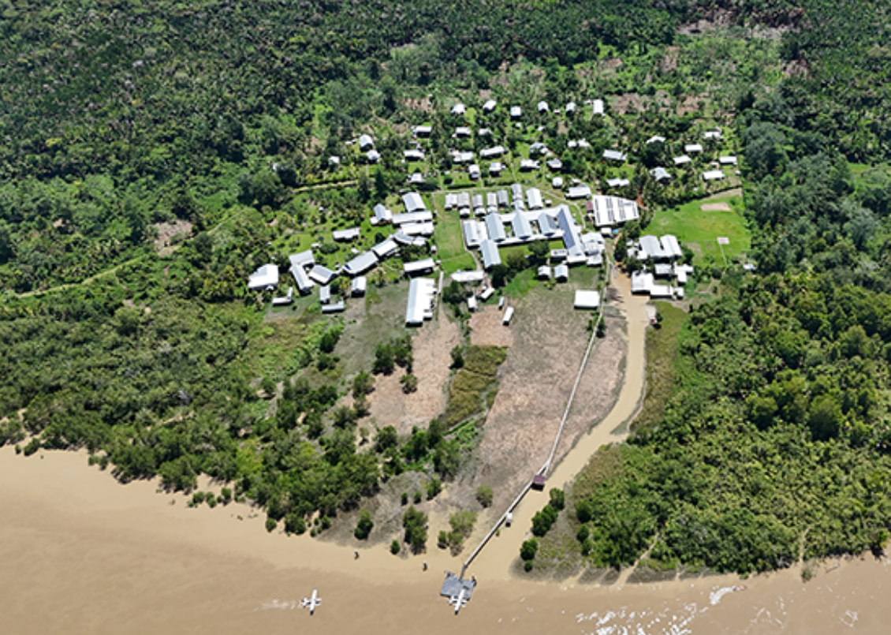Aerial Photo of Kapuna Hospital. Note 2 float planes (mentioned in letter) on the river).